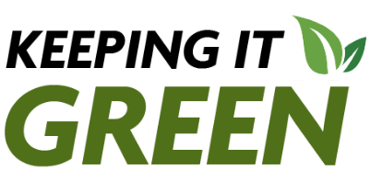
Keeping it Green: November 2025

Cortland ReUse partnership earns statewide award
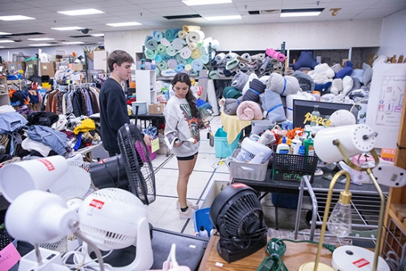
Congratulations to Cortland ReUse for winning the nonprofit sector award from the New York State Association for Reduction, Reuse and Recycling (NYSAR3). NYSAR3 highlighted The Red Dragon Reuse sale for reducing waste and finding new homes for dorm room staples.

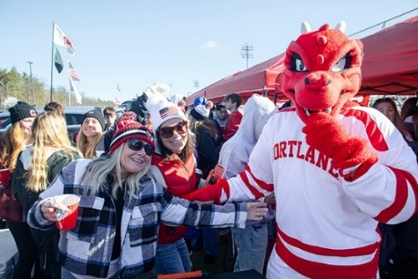
Cortaca Can Collection Competition promotes recycling

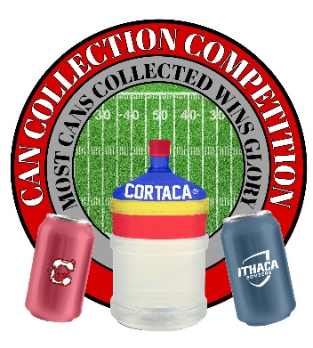
The two campuses are competing to collect 5-cent can deposits. SUNY Cortland and Ithaca College’s sustainability offices are joining forces to incorporate recycling into the popular football rivalry.
From Friday, Nov. 7, until Friday, Nov. 14, the two schools will compete in the Cortaca Can Collection Competition to see who can collect the most 5-cent can deposits. Collection sites will be at the Oscar machine in Hilltop and in the Student Life Center lobby.

21-Day Challenge promotes sustainable behaviors
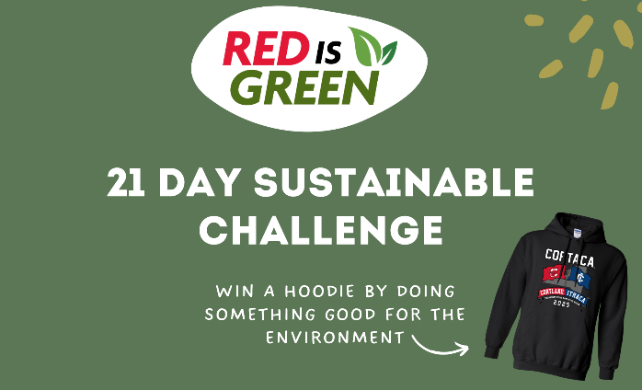
Until Wednesday, Nov. 12, the Sustainability Office’s Instagram account, @cortland.greenreps, will post a challenge of the day. Students have until midnight that day to complete the daily eco-challenge and submit their proof. More details on how to enter to win a Cortaca hoodie can be found on Instagram.
Applications open for SUNY Sustainability Awards
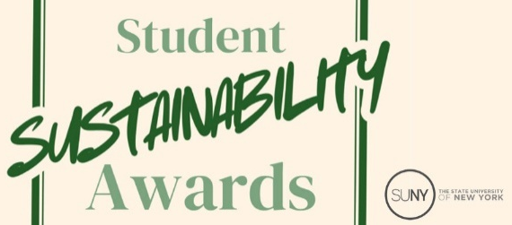
Applications are open for the new SUNY Student Sustainability Awards until November 14th. Undergraduate students involved in sustainability could be awarded a scholarship for the work they've done, plus a grant to host an event, activity, or program on campus. There is no nomination needed, all campuses are eligible, and there is no limit to the number of students applying from each campus. Apply today.

