
Keeping it Green: September 2025
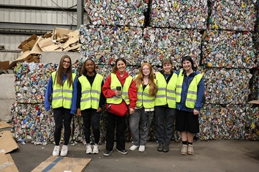
Green Reps learn about sustainability in Cortland Community
During their training, the Green Reps visited the Cortland County Recycling Center, Cortland ReUse and Lime Hollow Nature Center, to learn more about sustainable living off campus and get inspiration for their upcoming programs!

Implementing State-Wide Sustainability Mandates Across Campus

The Sustainability Office seeks campus support with implementation of Executive Order 22 and the SUNY single-use plastic ban through the launching of their new Green Procurement webpage. Attention all campus purchasers, please refer to the policies listed on our webpage prior to spending any state funds. Please reach out to sustainability@cortland.edu with any questions.

Campus Sustainability Updates
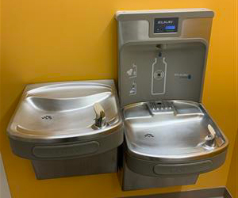
The Sustainability Office added a water bottle refill station map to their website and battery recycling collection containers to Residence Halls.

Red Dragon ReUse Donation Collection and Sale Recap

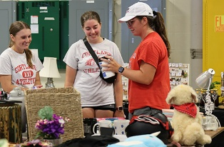
The third annual Red Dragon ReUse donation collection collected a record number of items and expanded to include a sale on campus.

SUNY Cortland Professor appointed Sustainability Faculty Fellow
The Sustainability Office wants to congratulate Jeremy Jiménez, associate professor of foundations and social advocacy, who was selected to be a Sustainability Faculty Fellow. This program will support bringing sustainability into coursework across academic disciplines.
Upcoming events
- Tuesday, September 16th : Green Reps bus to Cortland ReUse fundraiser concert. Sign up for a spot on the bus and to have admission covered with this form.
- Saturday, September 27th Green Rep bike ride to Kalash Kitchen. Sign up to reserve your free Outdoor Pursuits bike with this form.
- Tuesday, September 30th Counted Out investigates the biggest crises of our time, including climate change, through an unexpected lens: Math. 6 – 8 pm – Old Main Brown Auditorium
- Tuesday, October 21st: Sustainability Careers Alumni Panel, SLC 110 from 6-8pm. Hear from 3 alumni working in various sustainability fields about how their Cortland experience prepared them for their climate positive work.

SUNY Sustainability Conference
The SUNY Cortland Sustainability Office attended the SUNY Sustainability Conference hosted this year at SUNY Oneonta. Green Rep Kat Wilburn ‘26 was able to join to find new student engagement opportunities to bring to campus. Matt Brubaker, campus energy manager and Chief Sustainability Officer, presented lessons learned from a NYSERDA energy conservation project. Megan Swing, Cortland's energy and sustainability engagement coordinator, co-presented on completing the AASHE STARS 3.0 report.


Check us out on Instagram @cortland.greenreps !

