
Keeping it Green: May 2025
Move-Out Edition

Red Dragon ReUse
On campus students can drop off any donations in the donation totes and bins in their Residence Halls from May 5th through May 16th.
Off-campus students can drop-off any donations directly to Cortland ReUse (check out their website about donation details) or starting May 12th at the donation tote in the Student Life Center Lobby.

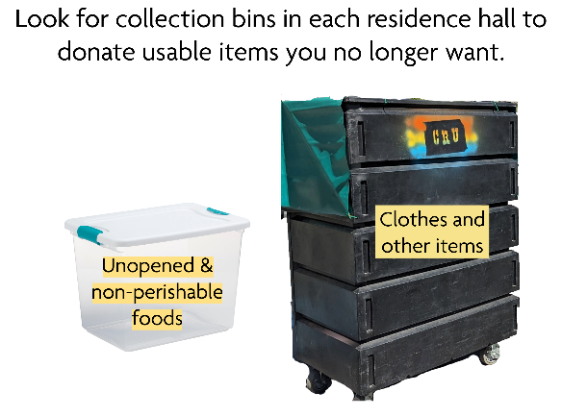
When you move out, don’t throw it out! DONATE!
- Unopened & non-perishable food items
- Dishes, silverware, pots & pans
- Printer paper, pens, scissors, and other office supplies
- Sheets, blankets, towels
- Lamps, small furniture, and other household items
- Electronic equipment
- Sports equipment
- Laundry soap, paper products
- Gently worn clothing
Your donations support the Cortland Cupboard, Student Emergency Fund, Cortland ReUse, and the local community!
If any employees would like to volunteer, please fill out this form by Friday, May 9th.
Grad Gown Donation
To our graduating seniors, congratulations on this huge accomplishment! We encourage the first thing you do as a Cortland alumni is to help support the next class of Red Dragons by donating your gown to the Cortland Cupboard!
Look for donation bins after commencement by the east-facing exit of Park Center and by the tennis courts.
If you aren’t ready to part with their gown right after the ceremony, there is still a way to donate! Alumni can mail their gowns to:
Megan Swing
Facilities Management
SUNY Cortland
P.O. Box 2000
Cortland, NY 13045
How to end the school year and spend your summer sustainably
By Green Rep Ava
End of the year moving out tips
- Skip the Bubble Wrap: Wrap fragile items in clothes, towels, or sheets instead of plastic wrap or packing peanuts.
- Donate, Don’t Dump: Don’t toss usable stuff! Donate clothes, furniture, and nonperishable food to Red Dragon ReUse, local shelters, or other donation drives.
- Pack with Purpose--Use bins, laundry baskets, and reusable bags instead of cardboard boxes and plastic wrap.
- Borrow instead of buying!
- Return or Reuse Textbooks: Sell, donate, or swap textbooks instead of letting them gather dust or go to waste.
- Upcycle Broken Items: Turn old t-shirts into cleaning rags or cushion breakables when packing. Reuse damaged posters as packing padding.
- Choose Sustainable Storage: If you’re storing stuff over the summer, look for ecofriendly companies or packs using reused containers.
- Sort E-Waste Properly: Got broken chargers or dead batteries? Don’t toss them, look for electronics recycling bins on or near campus.
- Plan Transportation Wisely: Carpool with friends or combine trips to reduce your carbon footprint
Summer Sustainability Tips
- Pull down shades during daytime hours to block out hot sun. Open windows at night if the temperature cools down, and capture cross breezes if possible.
- Fast fashion spikes in summer with new swimsuits and festival looks. Try thrifting or swapping with friends instead—it’s cheaper, more unique, and way better for the environment.
- Visit your farmer’s market to buy fresh, in-season fruits and veggies. This reduces transportation emissions and supports small, sustainable farms.
- Ice cream is synonymous with summer. It tastes delicious and cools you down. What’s more, being eco-friendly is in the palm of your hand. Order your scoops in a cone to eliminate the waste from single-use cups and spoons. Bonus points if you order a plant-based / dairy-free ice cream.
- To protect your skin without endangering marine life, use sunscreen that is reef-safe. Avoid products containing: oxybenzone, octinoxate, and octocrylene, especially at the ocean. Look for sunscreen with zinc oxide as an active ingredient.
- Spend your summer helping and volunteer! Check-out park or beach clean-ups in your area!
- When organizing summertime excursions, consider cycling, walking, or public transportation. To cut down on carbon emissions, carpool with friends or family if you’re going to the beach or a local park.
- Water your garden in the early morning or late evening to reduce evaporation. Use a rain barrel to collect water for plants and consider planting drought-resistant or native species.
- Shrink your carbon footprint and help cut air pollution by using electric grills, mowers, and other landscaping tools. When tools or appliances need to be replaced, consider electric options.
- Drinking plenty of water and eating water-rich foods like lettuce, cucumbers, melon, and citrus fruits can help you stay well hydrated. Utilize water-filling stations for reusable bottles to cut down on single-use plastic bottles and help save money at the grocery store.

