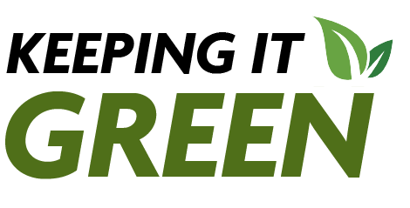
Keeping it Green: April 2025
Earth Month Edition
April is Earth Month at SUNY Cortland!
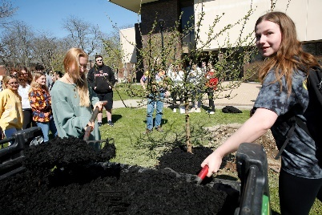
SUNY Cortland is getting ready to celebrate Earth Day the entire month of April. Check out the Sustainability Office’s calendar for information full schedule of events celebrates sustainability and environmental conservation. Know of an event that isn’t on our calendar? Email Megan Swing and she will add it.

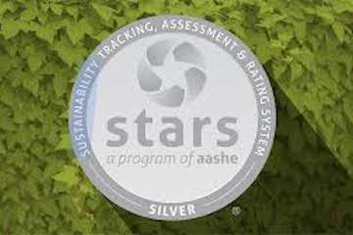
Campus sustainability efforts earn silver STARS
At SUNY Cortland, red continues to be green, according to new assessment. SUNY Cortland, for the fourth time, has been recognized for its sustainability initiatives. Cortland was the first in the SUNY system to receive this recognition in a new more robust version of the report from the Association for the Advancement of Sustainability in Higher Education (AASHE).
Sustainability Survey
You have an opportunity to help SUNY Cortland strengthen its reputation as one of the “greenest” colleges in the United States by completing the Sustainability Literacy and Carbon Intensity Survey. Students who complete the survey by April 18 can enter a random drawing with a chance to win one of six prizes: a pair of Spring Fling Tickets or one of 5 CAS gift card’s worth $50 each.
You can complete the survey online.
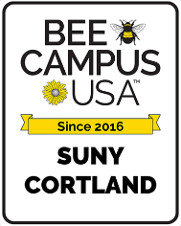
Bringing Buzz Back: Seniors Join the Fight to Save Pollinators
Bee Campus USA lecture shares a project of a PhD student to expand pollinator habitats with the help of assisted living facilities' residents. By Ava Brandon, Green Rep


Green Reps: Sustainability Stories for Earth Day
To celebrate Earth Day this year the Green Reps wrote articles about different sustainability topics.

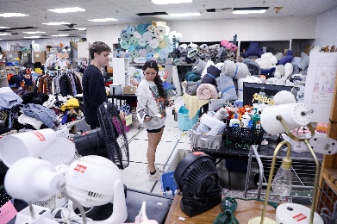
Get Ready for Red Dragon ReUse 2025!
The end of the semester is just around the corner! It’s time to start thinking about packing up your room. If there are items you don’t want to move out with you, consider donating them. For the third year in a row, SUNY Cortland will be partnering with Cortland ReUse to collected unwanted items from residence halls to be given a second life. More information will be coming soon!
Employees, please sign-up to volunteer at this link.
Cortland Coat Collection!
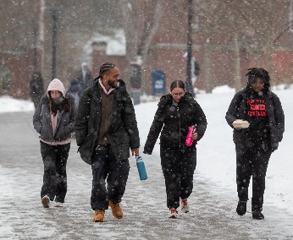
We are looking for gently used coats in good condition to establish a Winter Wardrobe dedicated to students. Donations are accepted Monday, April 28th – Friday, May 9th. Donations are being collected at:
- Student Affairs Office - Corey Union, Room 407
- Memorial Library – Lobby
- Student Life Center – Lobby
This initiative is brought to you from the collaboration of Care and Outreach Services, Cortland Cupboard, Health and Wellness Promotion, and the Sustainability Office.
Community Fun Fact
Cortland County Recycling also accepts regular household and rechargeable batteries and most electrical/electronic items for recycling.


Check us out on Instagram @cortland.greenreps !

