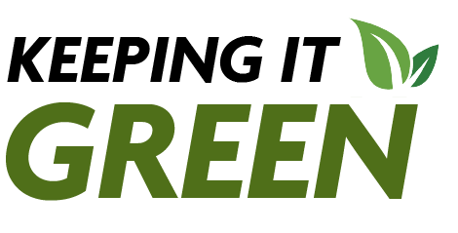
Keeping it Green: February 2025
SUNY Climate and Sustainability Action Plan | Meet the Spring 2025 Green Reps | Expanding Pollinator Habitat Zoom Presentation
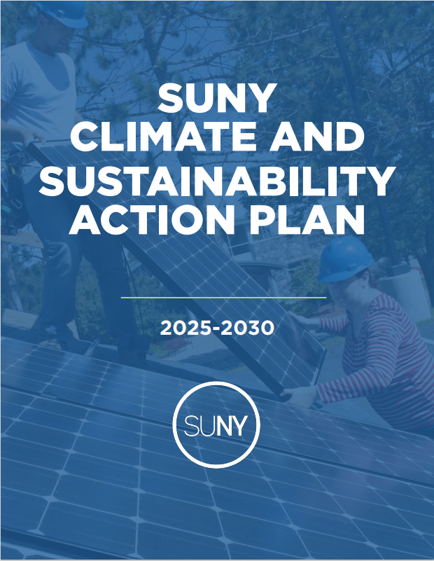 | 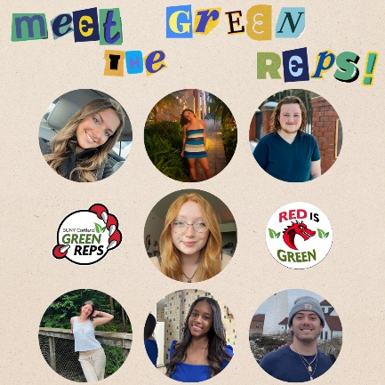 | 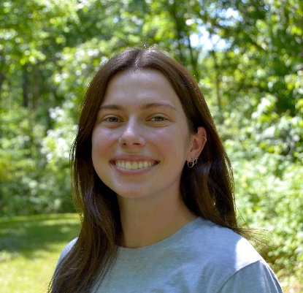
The SUNY Climate and Sustainability Action Plan provides a framework for decarbonizing the SUNY system, encompassing 64 schools, 40% of state-owned buildings, and 1.3 million students. This Plan will strengthen SUNY's achievement of the State's goals in the Climate Leadership and Community Protection Act and Executive Order 22 and consolidates and extends sustainability commitments already made by campuses. Its development was guided by the 53-person SUNY Sustainability Advisory Council, network of campus sustainability leaders, and public feedback. | To celebrate and kickoff the new year of sustainability advancements, we want to introduce our team of Green Reps!  The mission of the Green Reps is to inspire more earth-friendly lifestyles through peer-to-peer environmental education programs that will lead to a more eco-friendly and sustainable campus and lifelong behaviors.  We are planning some events including film screenings, sustainability trivia and reuse crafting sessions in residence halls and for the entire campus community! Keep an eye out for Green Rep programs, especially in April for Earth Day! | Join us for a presentation by Hannah Gurholt, a 3rd year PhD candidate at Cornell University and founder of Seniors Assisting Monarchs, about her research expanding pollinator habitat with the help of senior residents at assisted living facilities.  The presentation is happening on Zoom on February 25th at 4:30pm. Register using this link.  Hannah’s research is focused on the intersection between ecosystem and human health. She is studying how these pollinator gardens affect the mental wellbeing and sense of belonging amongst the senior residents.


Show the Earth Some Love this Valentine’s Day
Environmental Impact of Valentines Day
- According to the USDA, in 2022 the United States imported almost $3.3 billion worth of cut flowers, plants and nursey stock from 81 countries with imported fresh-cut roses accounting for more than $800 million. Roses totaled nearly a quarter of US floral imports!
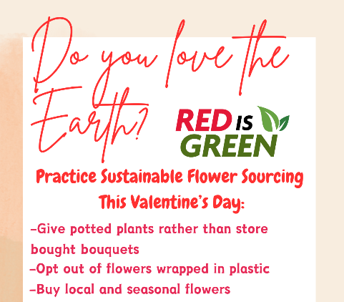
- In 2018, the International Council on Clean Transportation estimated 360,000 metric tons of CO2 were emitted through floral shipments from Colombia to the United States in a year, using 114 million liters of fuel. That’s equal to 15 times the annual carbon emission from SUNY Cortland! To remove that much carbon dioxide from the atmosphere it would take 361,101 acres of U.S. forests in one year. That’s just for shipping the flowers! There’s more emitted from growing and the production and transportation of the plastic flowers are typically wrapped in!
- For more information on sustainable flowers in preparation for any upcoming floral purchases check out Washington University in St. Louis’s webpage.
Tips from the Green Reps on how to have a sustainable Valentine’s Day
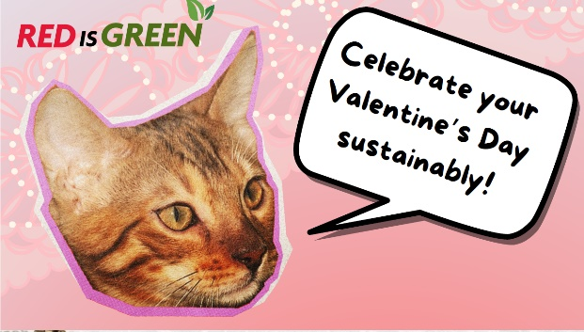
- Celebrate by gifting an experience – plan a hike or visit a local museum instead of giving a material item – Kat
- Fall in love with recycling – upcycle and repurpose your old clothes into something new. This could be a fun activity to do together! – Ava, Brianne & Daniella
- If you’re going to shop, shop at a local small business or second-hand! -- Kat
- Give potted plants rather than store bought bouquets. – Mario
- Avoid flowers wrapped in plastic! – Mario
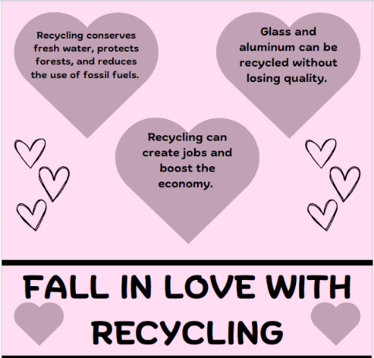
- Gift a treat – whether you make it yourself or visit a local candy shop or bakery. – Fiona
- You can bake a homemade sweet treat with some love and cut down on single-use plastic packaging! – Fiona
- Fuss free flowers – bring a vase to your local florist and have the flowers cut and prepped. This cuts down on wrapping materials. Bonus points if you thrift the vase or reuse an old jar! – Fiona
- Get crafty -- handmade cards and paper crafts are sure to be adored. Reuse gift bags. Avoid using glitter and using non-recyclable mixed materials. – Fiona
- Look for domestically grown and/or sustainably certified flowers. Some third-party certifications that check ecological and societal impacts are: Veriflora, BloomCheck, Fair Trade and Rainforest Alliance. -- Megan, Energy and Sustainability Engagement Coordinator
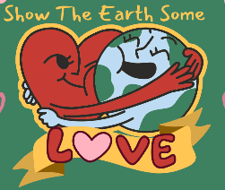
While these are more sustainable options, they are not without environmental impact. Paper crafts, locally grown flowers and homemade sweet treats all have their own footprint and effect the environment with the way the materials, even the most sustainable ones, are produced. Being mindful to reduce new materials you are using and consuming, and encouraging reuse to extend the lifespan are some of the first steps to a more sustainable lifestyle.

Community Fun Fact
Show the Earth and the Cortland community some love this month by supporting local florist! Buy local and seasonal flowers. Some places to buy in Cortland are: The Cortland Flower Shop, Floristry, Arnold’s Florist, and Shaw and Boehler Florist. – Mario, Green Rep | 

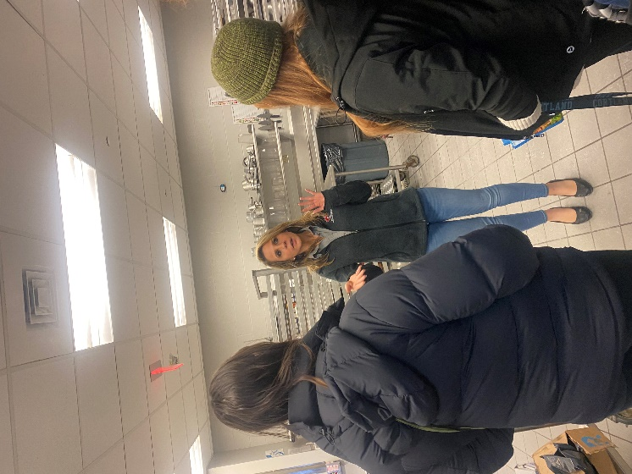
Green Rep Training featuring a former Green Rep
The Green Reps are starting the year off, green. Before classes started the team of Green Reps attended a training session full of environmental fun facts and updates and sustainable solutions. One of the students’ favorite parts of training was the presenters from local organizations encompassing many different parts of the spectrum of sustainability:
- Cortland Auxiliary Services – Chris Pecone, assistant dining director, spoke with students about the composting at the dining halls on campus. Before breaking for lunch the Green Reps got a behind-the-scenes tour from Aimee Szwalla, dining manager at Bistro to see what happens after putting your dish on the return, including the magic of the digestor that turns food waste into compost!
- Cortland County Recycling – Chris Spadolini, recycling coordinator, reviewed recycling rules with students and the importance of untainted recycling. Students had many questions about why recycling rules differ from county to county. Recycling correctly is a skill we all can improve on. We are looking forward to seeing recycling themed-programs and improving our recycling skills!! 😊
- Cortland ReUse— Carrie Narrow, executive director, gave insight into running a reuse center and thrift store and the other initiatives that are done to support the Cortland community.
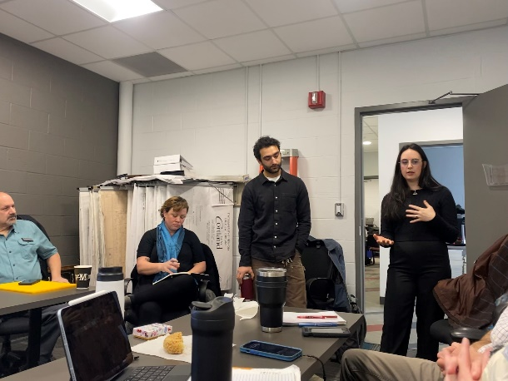
- Department of Environmental Conservation – Kim LaCoe, regional coordinator for waste reduction and recycling outreach & education shared the history of environmental and recycling laws and policies in New York state.
- Finger Lakes ReUse – Andrew Boghossian, deconstruction coordinator, and Lauren Sawyer ’21, workforce coordinator, discussed elements of the work Finger Lakes ReUse takes part in including e-waste, textile waste, construction and demolition waste, deconstruction, its value outcomes and an initiative know as CROWD, circularity, reuse, and zero waste development. Fun fact, when Lauren was a student at SUNY Cortland, she was a Green Rep – talk about a full circle moment!
- Waste Management – Mark George, area manager, brainstormed with the Green Reps different challenges they could face and how to plan fun programs to address them.

