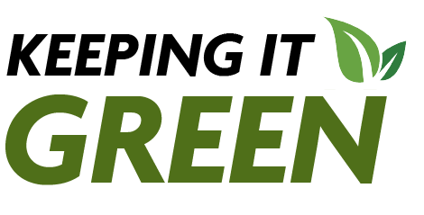
Keeping it Green: December 2024
Green Reps: What SUNY Cortland should know!
As the Green Reps wrap up an engaging semester, we are including articles from each Green Rep answering the big question: "What would you like everyone at SUNY Cortland to know?"
The climate clock is ticking  By Tiana Schelble | Considering our community: the Tioughnioga River  By Fiona Joss | Waste management at Cortland  By Nuala Seabrook
  Figure 1: Climate Clock (ClimateClock.World) | 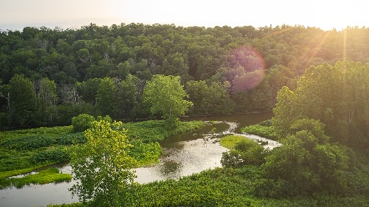  Figure 2: Tioughnioga River (Experience Cortland) | 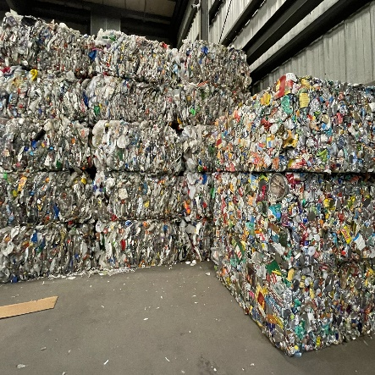  Figure 3: Cortland Recycling Center (Nuala Seabrook)
In four years, the Earth will be at a critical point, we are the generation that must make a change. | Nestled in the heart of Cortland, the Tioughnioga River is a gem for the community, and it needs to be protected. | One of the most important things the SUNY Cortland community can do to reduce waste is to recycle.

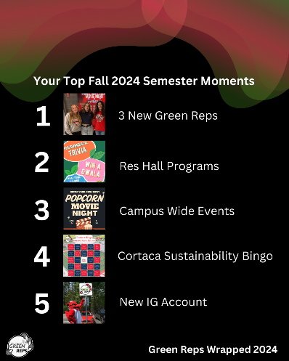
Green Reps Fall 2024 semester in review
The Green Reps and the Sustainability Office have been busy this semester. Here are a few highlights to look back on before we leap into the new year and new semester.
- Three Sisters Garden Harvest at SUNY Binghamton
- The “Scary” Facts of Halloween with Gorilla Corps
- GasLand & Bring Your Own Bowl (for Popcorn)
- Cortaca and America Recycles Day
- SCRA Eco-Swap and Green Rep Film Showing
Figure 4: SUNY Cortland Green Reps top Fall 2024 semester moments.
Food for Thought this Holiday Season
Gift sustainably – there are plenty of gift guides out this time of year. Check out these tips from the Washington Post on how to be more mindful when gifting, especially of the environmental footprint of your gifts.
Reducing food waste – eat, drink, and be merrily sustainable! The Washington Post shares how to how to enjoy your holiday favorites and maximize your enjoyment by not overcooking and getting creative with your leftovers!
Recycling – one thing you shouldn’t wish this holiday season is wish-cycle, aka put something into the recycling you wish could be recycled. The Washington Post shares how small plastics, like utensils and straws are too small for curbside recycling.
The importance of mindful consumption – While a new wardrobe might be tempting especially amongst all the haul videos you see on TikTok and Instagram, we ask you to consider if you really need it. AP News reports on the millions of garments shipped to Ghana each week, do you see any brands you recognize?
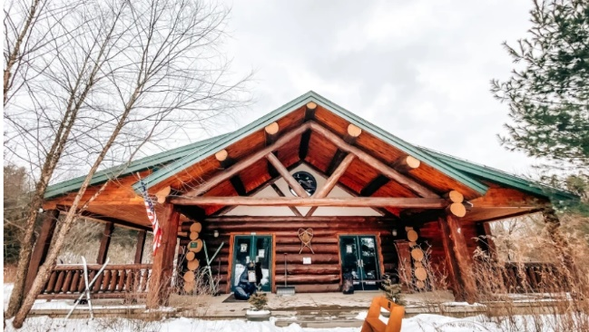
Community Fun Fact
Figure 5: Lime Hollow Visitor Center in the snow. (Experience Cortland)
Check out Experience Cortland to find small businesses to support. Gifting experiences like a restaurant gift certificate or upcycling a second-hand product are all gift-ideas this holiday season! For shopping second-hand check in Cortland out Cortland ReUse, Thrifty Shopper and Lot 1 Vintage. On Dec. 14, Outdoor Pursuits is taking a trip to the Lime Hollow Holiday Market. This is a great way to support local vendors and the Cortland community!
Newsletters of Months Past
If you ever want to revisit a newsletter or a story listed in a newsletter, you can! Check out the Sustainability News Page and the Keeping it Green Archive.
Coming in 2025
Five new Green Reps
More Green Rep events
AASHE STARS report
Earth Day 2025
Sustainability challenge
And more!

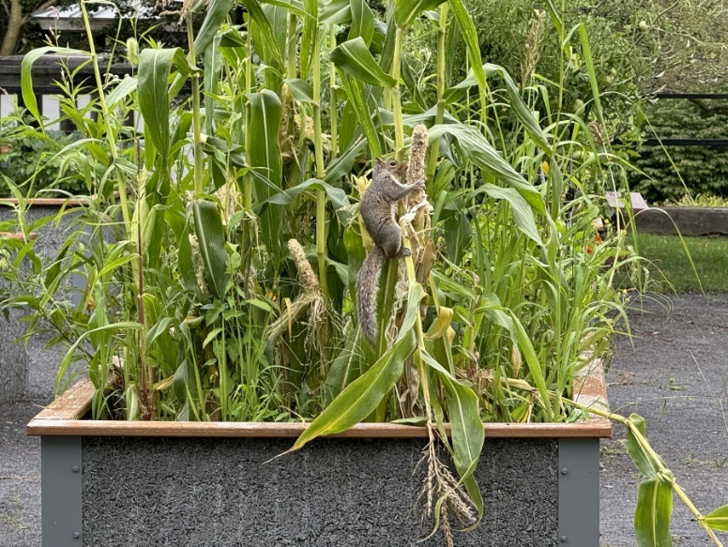
While technically this photo was taken before the Fall semester started, it was a notable moment from the year. Over the summer the squirrels enjoyed the corn planted in the Three Sisters Garden.
Figure 6: A squirrel eating corn planted in the SUNY Cortland Three Sisters Garden. (Beth Klein)

