
Keeping it Green: October 2024
University joins spotted lanternfly tracking effort |  | Introducing Terracycle |  | Celebrate AASHE Campus Sustainability Month with the Green Reps
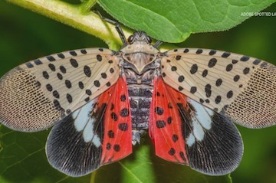 |  |  |  | 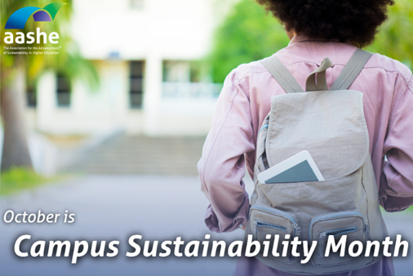
A trap near the Professional Studies Building is part of the largest invasive insect monitoring program in the Finger Lakes.  To that end, SUNY Cortland’s Sustainability Office has joined a regional early-warning effort to detect the arrival of the winged threat one bug at a time. The university this summer partnered with the Finger Lakes Partnership for Regional Invasive Species Management (PRISM) at Hobart and William Smith Colleges’ Finger Lakes Institute to host a trap on campus. |  | The Sustainability Office is excited to start to host TerraCycle collection programs. We are on a waitlist for a few of their programs, so keep an eye out for information about toothpaste, toothbrushes, deodorant containers, Brita filters and more programs coming soon!  Currently we are enrolled in the razor recycling program.  The program will work through collection bins all over campus in each of the residence halls. The bins aren’t there yet but will be soon!  All you need to do is put any of the accepted items in the bin and the Sustainability Office will take care of the rest. There will be a special and separate collection bin for razors to ensure the health and safety of everyone involved.  For more information about what we are currently collecting check out the Recycling page on the Sustainability Office’s website. |  | SUNY Cortland is proud to participate in Campus Sustainability Month throughout October. This annual event, hosted by the Association for the Advancement of Sustainability in Higher Education (AASHE), celebrates higher education sustainability achievements while raising awareness of the value of sustainability in higher education. To celebrate and kickoff a new year of sustainability advancements, we want to introduce our newest Green Reps and what to expect from the program!  The mission of the Green Reps is to inspire more earth-friendly lifestyles through peer-to-peer environmental education programs that will lead to a more eco-friendly and sustainable campus and lifelong behaviors.  We are in the works of planning some events ranging from film screenings to sustainability trivia and reuse crafting sessions. Keep an eye on your inbox and on Cortland Connect for events coming your way.  Interested in becoming a Green Rep for the spring semester? Find details and apply using their myRedDragon credentials at this secure link.
Meet the Green Reps!
Fiona Joss | Tiana Schelble | Nuala Seabrook
 |  | 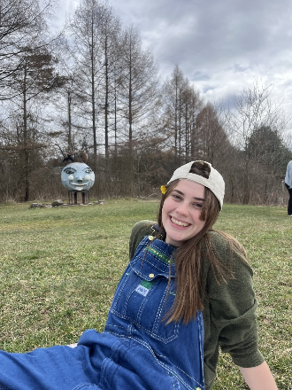
She/her  Major: Therapeutic Recreation  Why you wanted to become a Green Rep: Growing up, I was always disturbed by the amount of trash that lined my neighborhood. There was litter in every yard, bush line, fence, ditch, and tree. In recent years I’ve become more attuned to the problems our planet is facing, and how I can make my lifestyle less impactful on the planet. The Green Rep program here at Cortland allows me to spread awareness about environmental issues as well as offer solutions and alternatives to harmful habits. One of the three pillars of recreation is the conservation of places and spaces. I am passionate about improving the cleanliness of these areas, not only for the health of our planet but for the health of our community as well.  Favorite eco-tip: The three R’s (reduce, reuse, recycle) are in order of best practice! First, try to reduce your consumption of single-use or new products, then try to reuse the waste you generate, last if it can’t be reused; then you recycle what you can that is left. | She/her  Major: International studies with a concentration in health and environment  Why you wanted to become a Green Rep: I’ve always been passionate about living my life as green as possible and in the future, I hope to put efforts towards getting environmental and animal rights policies passed on a global level. When I found out this was a position at Cortland, I hopped on the opportunity to help spread awareness throughout the student body on environmental issues. We need everyone working together to make real change and I’m hoping I can inspire my classmates to do so  Favorite eco-tip: You can replace cling/plastic wrap with eco-friendly beeswax wraps. Reuse zip blocks. Although it sounds self-explanatory many people don’t reuse their zip block bags after use. | She/her  Major: Outdoor Recreation  Minor: Communication and Media Studies  Why you wanted to become a Green Rep: All my life I have always loved nature and being outdoors. In recent years, learning more about the climate crisis and the path the planet is on has made me want to promote sustainable actions and educate others about their role in the planet’s ecosystem. Being a green rep is a good first step in educating fellow students about easy ways to live more sustainably, and why that is important in the long run.  Favorite eco-tip: Be mindful about where and how you shop! Thrifting is a great alternative to fast fashion and online shopping for many reasons. Thrifting reduces waste, your carbon footprint, and promotes a circular economy (all while saving money!) In addition, buying furniture and household items from Reuse and thrift stores is also a great way to shop sustainably.

Apply to be a Green Rep for the Spring 2025 Semester.
Find details and apply using their myRedDragon credentials at this secure link.

Community Fun Fact: Getting ready to study abroad? The International Programs Office has resources on how to study abroad sustainably? From programs that focus on sustainability to packing guides and carbon offsets.

How to Have a Sustainable Halloween from Defenders of Wildlife:
Here are a few that are particularly applicable to college students
DIY, Swap or Secondhand Costumes – Making your own, swapping with friends or opting for secondhand costumes extends the life of the costume and prevents more from ending up in landfills (plus it will probably be cheaper)

Introducing Sustainability Wordle (with a prize)!
Play the Sustainability Office’s Wordle. The first five people who send their game stats to Sustainability@cortland.edu will win a prize!

Did you see the photo Beth Klein, campus sustainability coordinator, took of the northern lights earlier this month?

