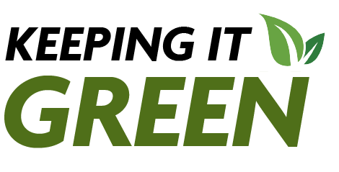
About Keeping it Green
Keeping It Green is your monthly guide to everything sustainability that's happening at SUNY Cortland. Readers should anticipate stories about sustainability initiatives on campus, how to get involved in campus sustainability, related events and more! If you want to participate in campus sustainability and/or have an idea for a story, send an email to the Office of Sustainability at sustainability@cortland.edu.
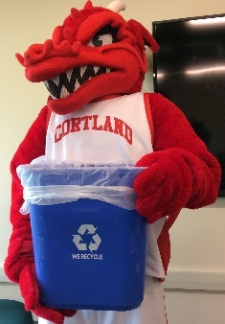
Recycling in Cortland - probably different than at home!
Red Dragons recycle! We want to ensure that you have a ‘green’ start to the semester, so we wanted to talk a bit about recycling on campus and in Cortland County, as they differ from county to county.

Recyclable
- Plastic (Type 1, 2 and 5)
- Paper
- Cardboard
- Tin cans
- Aluminum cans
NOT Recyclable
- Food-soiled items
- Paper milk/juice containers with plastic spouts
- Foam plastic containers including
- Styrofoam
- Bubble wrap
- Plastic packaging containers
- Soft plastic bags

Taking it one step further- reduce!
Recycling is an important part of creating a sustainable campus. If you are looking to go a step further, there are many ways to do so. Avoid plastic cups from cafes and coffee shops by bringing your own. Reuse what you have – whether it’s a brown paper bag from the grocery store as wrapping paper or a glass jar for storage. Get creative! Ask to borrow something from a friend rather than buying something new.
For more information visit the Recycling webpage on the SUNY Cortland Sustainability page.

Green Reps Return
Red is Green... Reps, we are looking for students to bring sustainability to the campus community. The Green Rep program’s mission is to inspire sustainable lifestyles through peer-to-peer environmental education programs that will lead to a more eco-friendly and sustainable campus and lifelong behaviors. Through this work a student could make a difference on campus and in the Cortland community and develop professional leadership, event planning, communication and peer education skills.
Are you interested in working to make campus, and the world, more sustainable and environmentally literate? Apply to become a Green Rep.

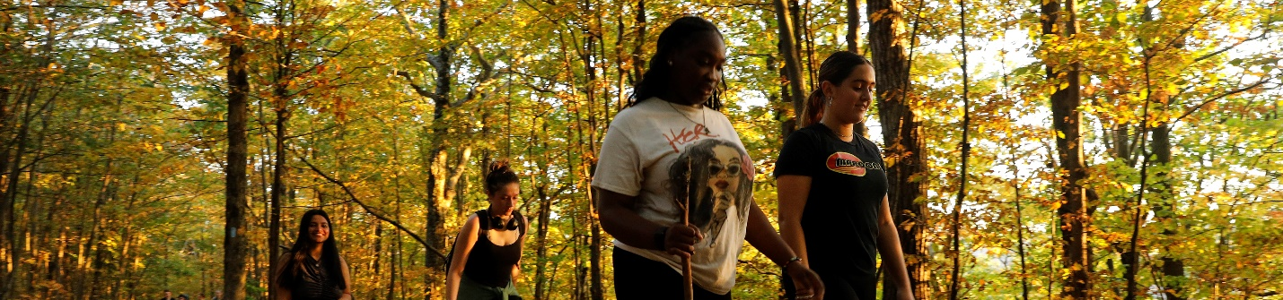Hike your way through Cortland
The Sustainability Office encourages you to get out and explore the surrounding natural environment. It’s a great way to connect with nature and learn more about the ecosystems surrounding you. So, get out there and explore, and even better carpool with friends while doing so!
Lime Hollow Nature Center
Lime Hollow Nature Center is a nature preserve with 13 miles of trails, and it’s about 5 miles from campus. From walking and hiking in the fall, spring and summer to snowshoeing and cross-country skiing in the winter, there is always something to do, no matter the season.
Hoxie Gorge State Forest
Hoxie Gorge State Forest is about seven miles from campus. There are a variety of recreational activities you can enjoy at Hoxie Gorge, including hiking, fishing, snowshoeing and more! There are also two separate segments of accessible trails for those with impaired mobility.

Register to Vote
Election Day, Tuesday, Nov. 5, is three months away. Now is a perfect time to get ready to take advantage of the opportunity to vote for a new set of elected officials into office.
It may not seem like it, but voting and being informed about policy positions of candidates as well as any bills on the ballot are great ways to get involved in sustainability. We are not advocating for you to vote one way or another, but we are encouraging you to show up at the polls and vote this Election Day.
Helpful links:
Online Voter Registration – New York state
Vote 411 – Election information you need

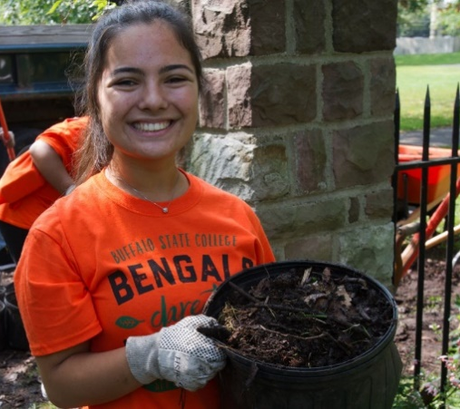SUNY Empire State Service Corps
If you have a desire to do good and make a difference, you can get hands-on experience and serve your community through paid public service with the Empire State Service Corps. These opportunities allow New York students to be paid for meaningful work that can provide lifelong skills as well as service to their community.
SUNY Cortland is participating in SUNY’s new Empire State Service Corps, which gives economically disadvantaged students the opportunity to intern in socially and professionally beneficial projects.

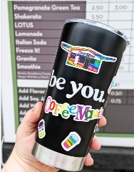Community fun fact – take reusable cups to Coffee Mania they will refill! Mugs must be clean and dry. Avoid single-use plastic cups.

More Sustainability Stories at SUNY Cortland 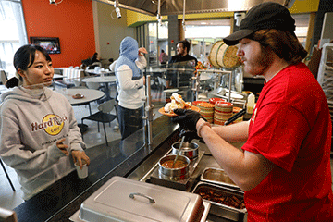
Cortland honored nationally for sustainable food service
University’s Weigh the Waste Earth Day event captured a bronze award among its collegiate peers.

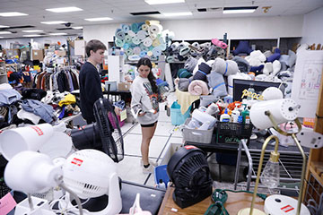

Residence hall donations get a second life
SUNY Cortland partnered with Cortland ReUse to collect departing students’ unwanted items.

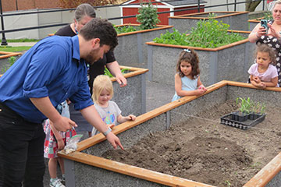

New garden celebrates Indigenous crops and culture
The Three Sisters farming method is introduced to SUNY Cortland’s Model Garden.

